Notice to Competitors No. 5

Sign on procedures for 2021 Winter Series Race 3

It is essential that ORCV has the correct POB information prior to the commencement of each race.

As skipper, it is your responsibility to provide such information via your Top Yacht entry. The ORCV office can assist you with this process if you are unsure how to add/drop crew.

We understand that crew changes can occur at the last minute, however, should you experience an issue during the race ORCV need to know correct POB onboard.

Please continue to add in your crew via your Top Yacht entry as per the date indicated in the NOR. In addition to this method of adding crew, we will be sending you a SMS link like the one below at approximately 1630 on Friday 30th July 2021. This link will make it easier for you to update your crew listing at the last minute and provide final confirmation of who is on board before sign on.

Note it may well be a good idea to delegate this task to one of your crew on Saturday morning so you can concentrate on getting your boat ready for leaving the pen.

Example link - http://tymob.net.au/mycrew.php?evid=1356

You can find this link in your Top Yacht entry page if you wish to save it to you phone.

The link we send you will take you to a page on Top Yacht, where you enter your sail number and your TES password.

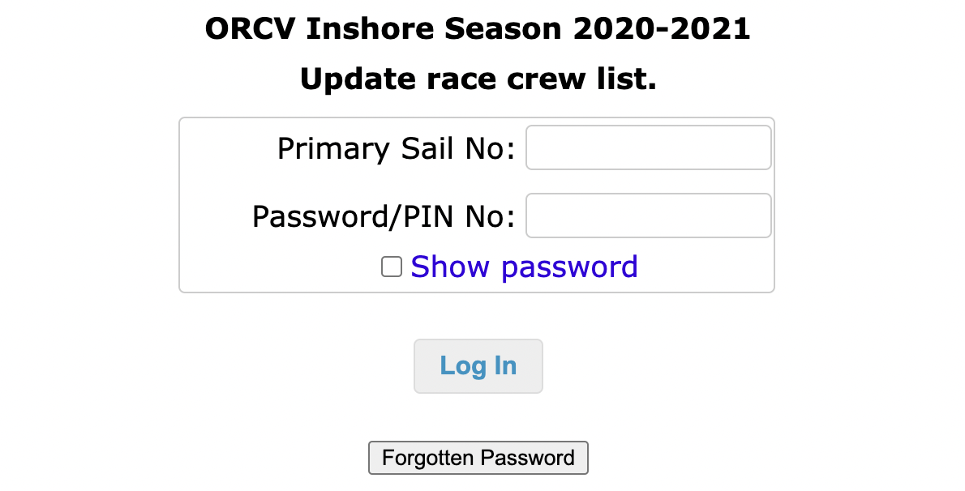

Once logged in, please select the upcoming race and click update crew

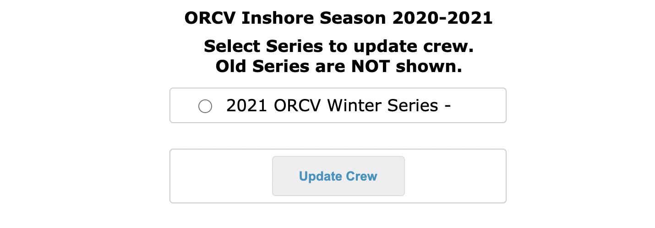
You will now see a page listing the crew that you have previously added for this race, along with an option to add crew via the “Get Existing Crew” or “Create a New Crew” buttons.

If you need to add new crew, it may be easier at this step to pass your phone to the new crew member and have them add their details.

Once all crew members on board are listed, you must tick the “On Board” box next to the name of each crew participating in this race. By ticking this box, the Race Director is provided with the final and correct number of POB. In the event of an incident, the RD may then access the individual crew information you have provided, but initially it is the confirmed POB that is important.

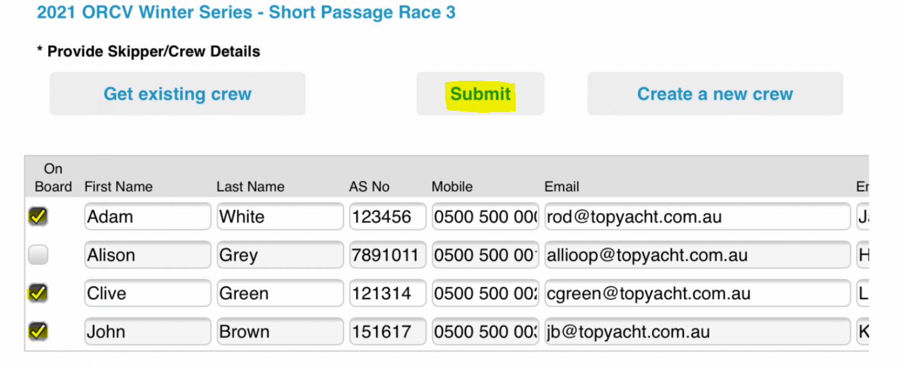
Once your crew is complete you must click the submit button which will display a screen like this.
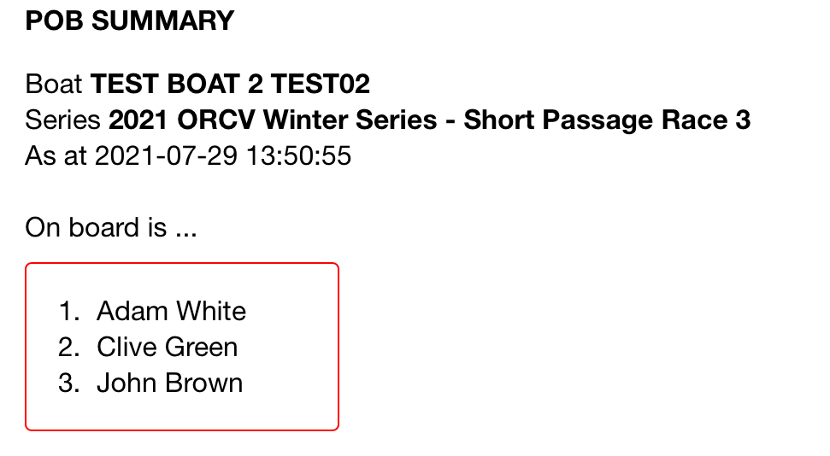

It is important that all fields have complete and correct information on all crew and the emergency contact is not sailing in the same race.

If you don’t know your Australian Sailing number (previously called your YV Number), you can find it here - Check my Australian Sailing Number

If you don’t have an active Australian Sailing number, you will need to obtain a temporary AS number by purchasing a Bay Pass for $20 from ORCV here: ORCV Bay Pass

If you need any assistance, please call the ORCV office on 9088 7210 during office hours.

Jeremy Walton
Sail Captain
29 July 2021

